Intro
Azure Analysis services (AAS) is server where semantic models can be created to support a given data model.
There are to ways to maintains data models :
- Using a dedicated Azure resource (AAS)
- Power bi Shared data set

AAS
You need to have or create a AAS server form azure portal , witch will provide a server name
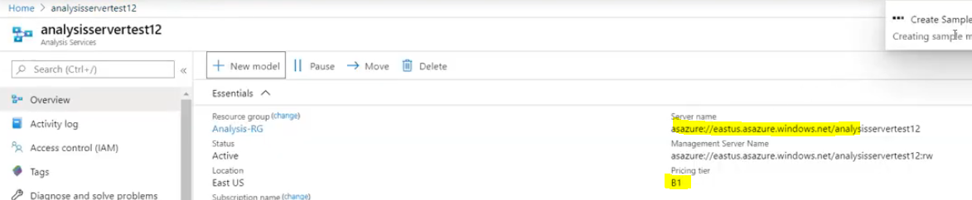

Create
https://www.youtube.com/watch?v=_HzjCbOF4Fg

Cost
To handle large data volumes, we need more memory and more QPUs while processing the AAS models
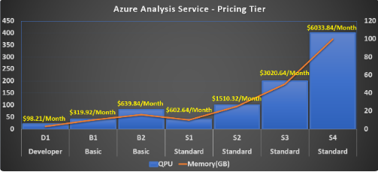
https://www.linkedin.com/pulse/how-optimize-costs-when-using-azure-analysis-services-velamakanti/

Roles

Sources / SQL DB / Synapse

SQL DB
Import mode with Incremental or full refresh
Direct query , query directly the tables in the DB , a report load time

Synapse

Processing

Power BI shared Data set

